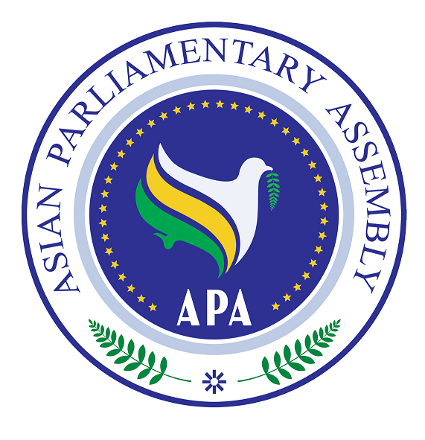

SG/Rep/2010/03
2 March 2010

The Report of

the APA Secretary-General

on

Challenges and Opportunities of Globalization in Asia
Background
The Sub-Committee on Challenges and Opportunities of Globalization in Asia held its meeting on 19 June, 2009 in Jakarta and considered the report of the Secretary-General and adopted its Report including the resolution to be submitted to the Executive Council. The first Executive Council of Asian Parliamentary Assembly in 2009 held its meeting on 11-12 August 2009 in Jakarta, and approved the Report of the Sub-Committee. The fourth APA Plenary met on 7-10 December 2009 in Bandung, Indonesia, and approved the resolution on Challenges and opportunities of Globalization in Asia. (APA/Res/2009/04)

Introduction
The resolution decided to mandate the Sub-Committee to continue to work. It underlined the significant role of parliaments both in strengthening national policies and in harmonizing Asian approach in dealing with Globalization. It also expressed the need for easy access to information, communication, and new technologies globally. It supported the view that global net-working provides opportunities for Member Parliaments to engage in fruitful dialogue on important issues for Asia. It also expressed its dissatisfaction about the negative impact of Globalization on widening the gap between the rich and the poor as well as cultural hegemony on Asian societies. It further decided to establish a networking relationship between APA and major institutions dealing with globalization impact in each Asian country. The resolution requested the Secretary General to continue his work on establishing the “Asian Virtual Parliament”. It also underlined the importance of the adoption of a common legislation.
Accordingly the present Report is submitted to the Committee for its consideration on three major issues:

I- Harmonized Asian approach on globalization
Globalization both conceptually and practically has been subject of debates and controversies in academia and politics and resists any single definition. However, It has mostly been characterized as the integration of regional economies, societies, and cultures through a globe network of communication and trade. These interdependent processes have transformed human interactions at all local, national, regional and global levels. It has progressively brought in a new era of interconnected economic and social relations. In economy, globalization has resulted in creation of a global common market, based on the freedom of exchange of goods and capital. However, this may lead to economic destabilizations and marginalization of developing countries.

In social and cultural fields global culture strongly undermines the social and cultural identity of different communities and weakens the traditional social institutions. Information technology has revolutionized the world communication. The internet breaks down cultural boundaries across the world by enabling easy communication between people in a variety of digital forms and media. In politics, global networking and international actors either governmental or none governmental are playing unprecedented roles beyond traditional Nation-State boundaries.

The APA Resolution on Challenges and Opportunities of Globalization in Asia underlines the importance of consensus-building and development of a harmonized position toward golobalization. APA can play a great role in developing a harmonized Asian approach regarding the impact of globalization in Asia. The exchange of views and ideas on paradoxical issues relating to global processes and sharing experiences on how different countries have dealt with them successfully would pave the way for developing a more concerted approach. For so doing, the Secretary General would like to draw the attention of parliamentarians to following issues to be discussed in certain workshops or a Forum.
Globalization as a comprehensive process encompasses economy, polity and culture; to what extent is it possible to strike a balance between these fundamental aspects in Asia? In economy how has globalization affected Asian market, trade, employment, labor, investment and finance? To what degree has it helped or hindered the economic development in Asia? Has it contributed to a sustainable development or has it widened the gap between the rich and the poor?
On cultural issues, what is the relationship between globalization and localization, are they compatible or not? To what extent can globalization be identified with the Westernization in Asia? Is it justifiable to regard cultural globalization, as a process of homogenization and the global domination of western culture at the expense of traditional diversity? In political affairs, to what degree globalization may undermine the national sovereignty of Asian countries?

II -On Common Legislation
Operative 6 of the Resolution underlined the importance of the adoption of a common legislation among Member Parliaments on Reform of Global Financial System and on Bridging the Digital Divide in Asia. The role of Asian Parliaments in addressing global impact of current financial system on economy and society of Asian countries is of outmost importance. The APA Committee on Financial Crisis would exclusively work on how to cope with this situation and elaborate on more effective and credible regulations to ensure global transparency and enforceable monitoring mechanism.
On Bridging the Digital Divide in Asia the Secretary General would like to reiteraite that easy access to information technology is of vital significance in dealing with rapid structural and digital developments. This necessitates taking practical steps to narrow the digital divide among Asian countries as well as Asia and the World. The Secretary General suggests that at least three Member Parliaments to volunteer for studying the possibility of drafting a common legislation on Narrowing Digital Divide in Asia and prepare a framework for further action by the Committee.

III_- The Virtual Asian Parliamentary Assembly (APA)
Operative 5 of The Resolution requested the Secretary General to report to the Committee the financial and technical requirements for establishing the “Asian Virtual Parliament”. Taking practical measures toward integration in Asia requires cohesive mechanism and effective institutions. The Establishment of the Virtual Parliament can be an effective step for enhancing dialogue and exchange of views among Asian Parliaments for further cooperation and coordination.

The Secretary General in his previous report to the committee highlighted that the virtual parliament is not to substitute the current activities of the APA, such as the Plenary, Executive Council, Standing Committees and Sub-Committees; rather it is designed to further enrich the APA’s deliberations in a continuous way in the intervals of Committee Meetings. In fact, taking advantage of information technology would provide better grounds for deliberations and discussions among APA’s members in a much easier, inexpensive and faster manner.
The Virtual Parliament would facilitate dialogue by providing sufficient time and space for member’s participation and enrich the deliberations by addressing different dimensions of issues. It also provides opportunity to invite experts and advisors to participate in e-debates. In this way, APA’s deliberations will not be confined to scheduled meetings that take place in different countries, but will continue, according to a timetable, via video-conferencing among members in order to draft proposals for upcoming meetings.

Technical Requirements:
A video-conference is a set of interactive telecommunication technologies that integrate s video and voice to connect users with each other as if they are in the same meeting. Users see and hear each other at the same time and experience each others voice and image in a live and real manner. By using computer and entering username and password, this system allows the user to enter the conference and contribute to the meeting. The webcam and microphone attached to one’s computer would send the user’s voice and image to the members present at the conference. When parties are unable to meet in one place; Video-conferencing is widely used for live conversations, sharing visual information. The proposed method will operate on one’s computer just by using a web-browser; it does not require the download of any software.

Video-conferencing facilitates: face-to-face online meetings, voting ability using a username and password, automatic recording of the meetings, live interpretation services, sharing information, chairing the meetings with a chair-secretary system. The text and documents could be displayed at the same time as the speaker is giving his or her speech. In addition, since the speaker can also see and hear the rest of the members, a cooperating atmosphere will be created.
To use this system, a computer, a webcam and a microphone are required. If there is more than one person behind a computer, video projection can be used to facilitate the procedure. The internet speed required to use this system is at least 128 kilobytes per second. A high internet speed can affect the quality of your experience. In addition, if necessary, fingerprint or PIN codes could be used as passwords for voting in the system.

Recommendations
- The Committee supports the idea to work on achieving a common approach on globalization in Asia through holding certain workshops or Forums among Asian parliamentarians.
- The Committee deems it necessary to exchange views and share best practices on globalization impact in Asia and further designing a networking relationship among major governmental and non-governmental institutions active in the field of globalization with the view to formulate a common strategy. Establishing a networking relationship at national and continental levels would enable parliaments to better coordinate to adopt common plan for addressing digital divide
- The Committee supports the proposal made by the Secretary General that at least three Member Parliaments to volunteer for studying the possibility of drafting a common legislation on Narrowing Digital Divide in Asia and prepare a framework for further action by the Committee.
- The Sub-Committee welcomes the important report of the Secretary General on “The Virtual Asian Parliamentary Assembly” and requests him to further study the requirements for its implementation. It also requests the Secretary General to consult with Member Parliaments and seek their assistance to provide technical facilities and voluntary contribution.

